**Meeting Minutes – Iowa DOT June 16th, 2016**

**Guide to Data and Information Sharing Workflows across the Life Cycle of Transportation Assets**

**Attendees:** Brad Cutler GIS Program Administrator [brad.cutler@dot.iowa.gov](mailto:brad.cutler@dot.iowa.gov)

John Sebastian Project Engineer [John.Sebastian@dot.iowa.gov](mailto:John.Sebastian@dot.iowa.gov)

Sign replacement during construction projects

Zac Abrams Project Engineer – Sign Designer [zachary.abrams@dot.iowa.gov](mailto:zachary.abrams@dot.iowa.gov)

Dave Matulac Traffic Operations Engineer [David.Matulac@dot.iowa.gov](mailto:David.Matulac@dot.iowa.gov)

Maintenance of installed signs – not related to construction projects

**Software used for signing design:**

* Sign Inventory:
  + It is not widely used during design. Zac prefer to use Google Earth or RoadView to determine the actual location of the signs.
  + Data in sign inventory include size, color, message, location, etc.
  + Data is manually entered by design or maintenance staff.
* Google Earth:
  + Use to determine current and future location of signs.
* RoadView
  + Use to determine current and future location of signs.
* SignCAD:
  + Use to design signs in 3D. Once the design is complete, it is exported to Microstation.
* Microstation:
  + Use to geolocate signs.
  + 3D models are used to produce 2D files. 2D files are static.
  + Microstation shows dynamic information: Dimensions, geolocated coordinates at ground level and lower left corner of the sign, sign type, and sign identification number (Road-County-Exit#-Sequential# - e.g. 30-27-246B-M0003). See screenshot below.

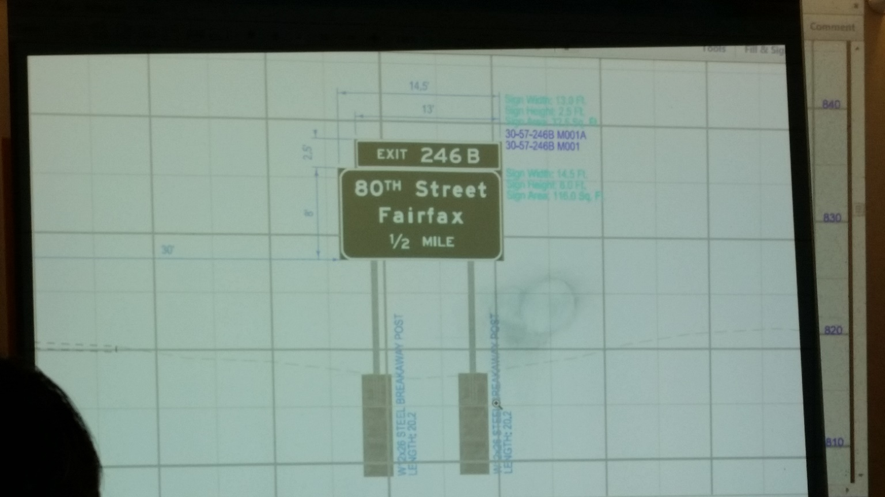

From Interchange construction project – Cedar Rapids

US 30 and 80 Street

* MS Excel:
  + Design information is summarized
* Adobe Acrobat:
  + Final signing design is summarized in a PDF file.

**Manuals and other Sources of information:**

* Sign Inventory User’s Guide
* Iowa DOT Standard Specifications – Division 25 Miscellaneous Construction
  + Section 2524 – Highway Signing
  + Section 2525 – Traffic Signalization
  + Section 2545 – Overlay of Type “B” Guide Signs
* Iowa DOT Standard Road Plans
  + Signs Section (SI)
* Sign Truss Standards

**Relevant comments and information**

* Changes made on the design (e.g. location of signs – Construction engineers can move signs within 50 ft either way) during construction are not made on the original design (Microstation files). They are added to the contract through amendments (PDF). They consider it would be convenient to create a feedback loop to modify original design files (Microstation) based on changes done during construction.
* Signing design team’s final product is a PDF to be sent to the Contracts Office. There is no standard format for this PDF, but it must follows some minimum requirements. PDF organization may vary from person-to-person.
* Some years ago they used designs from previous projects to start signing design for new projects. They still do it, but they are in the process of developing signing standard templates.
* Signing design activities and allocation of design responsibilities are discussed during the Production Schedule Meetings.
  + Production Schedule Meetings are held every other month. This is a six-hour meeting; one hour per district. All departments involved in design activities attend this meeting.
* Sometimes, signing design teams are assigned work two weeks before the beginning of work.\
* Signing activities conducted during construction projects are usually performed by the end of the projects.
* Different design departments use Microstation to work in the same geographical space at the same time (real time updates). They can see what other departments are doing. There is communication between departments to address conflicts, but there are no standard communication protocols.
* Tabular data can be obtained from Microstation. The current format of these tables is not useful. They have to manually enter this data into MS Excel spreadsheets. They mentioned it would be convenient if they could use Microstation tabular data to auto-populate the Excel spreadsheets.
* During signing design, they have some freedom to adjust dimensions based on the sign message, but following some minimum size requirements.
* Is sign is installed in truss or cantilever, it must follow federal restrictions.
* They use standard assemblies in their designs. See example below.
* One change in the design (before submitting final design) requires four inputs from three different programs.

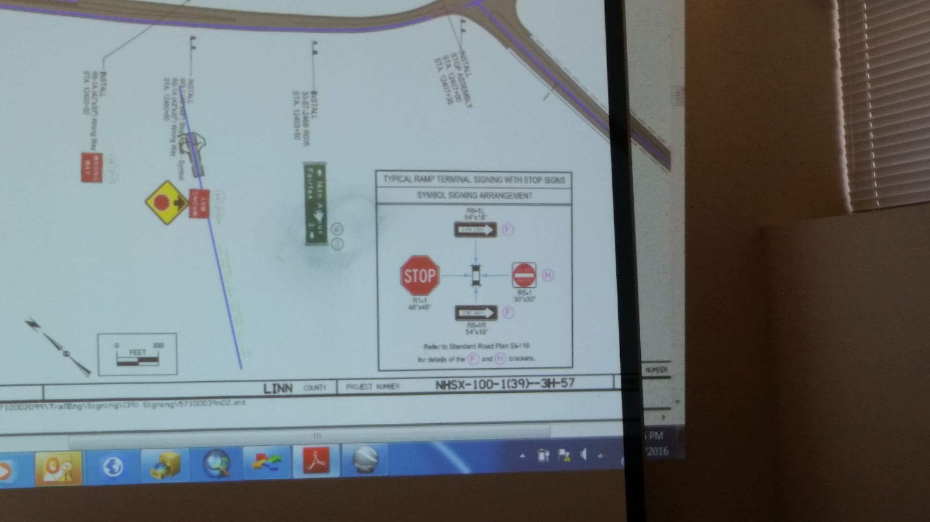

From Interchange construction project – Cedar Rapids

US 30 and 80 Street

* Dave: Changes made in existing signs are made in the Sign Inventory either by Dave or the maintenance staff. They have to coordinate who is going to do it.
* All plans and documents related to signing design are saved in a database in a folder named with their respective Project Identification Number. After a certain time after completion of the project, these documents are moved to the Electronic Record Management Systems (ERMS). All documents in the ERMS are saved as static images, including CAD files and as-built drawings.
* Once the signing design is complete, the design team must inform via email to all offices and staff included in a list.
* Bid items are quantities are stated in the Excel spreadsheet and they are also indicated in the plans. There is no link between the spreadsheets and the plans. Therefore, any changes in the bid items and quantities must be made in both files. Bid items are determine and identified based on the Project Scheduling System.
* Bid items and quantities are presented in two different tables:
  + Estimated Project Quantities
  + Estimated Reference Information – Relevant comments about each item (e.g. how it will be paid and measured if not indicated in the Iowa DOT Standard Specifications).
* Signs are usually provided to contractors by the DOT.
* In the past, it was common for sign fabricators to ask for the digital files given that they used the same software used by the DOT. This practice is getting less common, but it is not clear why.
* The design and sign specifications are sent to the sign fabricator, which are used to create shop drawings. Shop drawings are then sent to the DOT for approval. Fabrication can begin upon approval of the shop drawings from the DOT. Regardless of the approval of the shop drawings, the fabricator is still responsible for any errors in the final product.
* Zac is going to send to Dr. Jeong the contact information of sign fabricators working with the Iowa DOT (Including Rocal).
* Signing design activities are easier for new construction projects given that in reconstruction projects design teams have to deal with existing signs, which must be identified and located.
* Actual location of existing signs should be also indicated in the existing conditions survey.